***BIG DATA LEC 1***

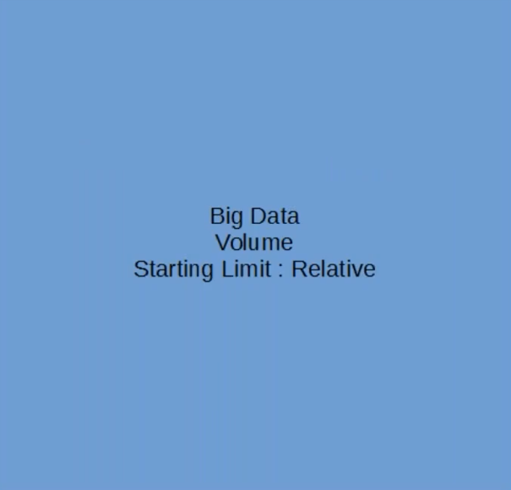

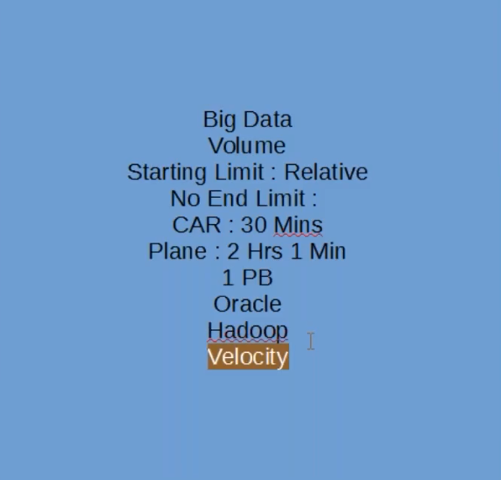

***Velococity***

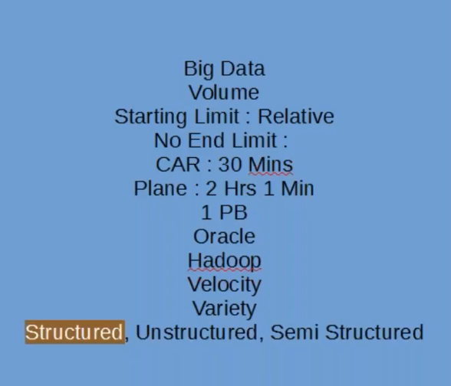

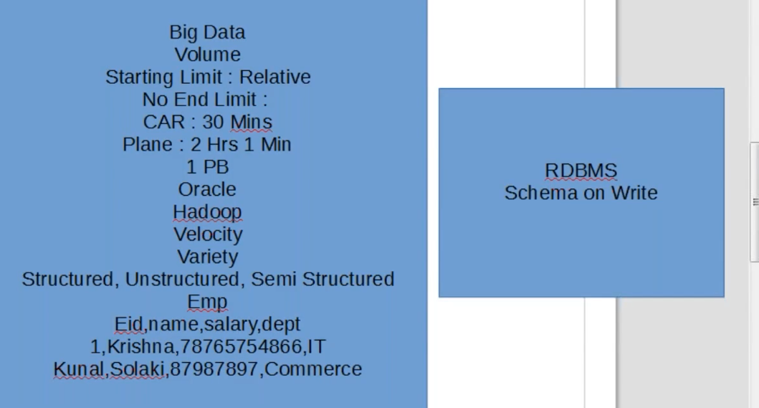

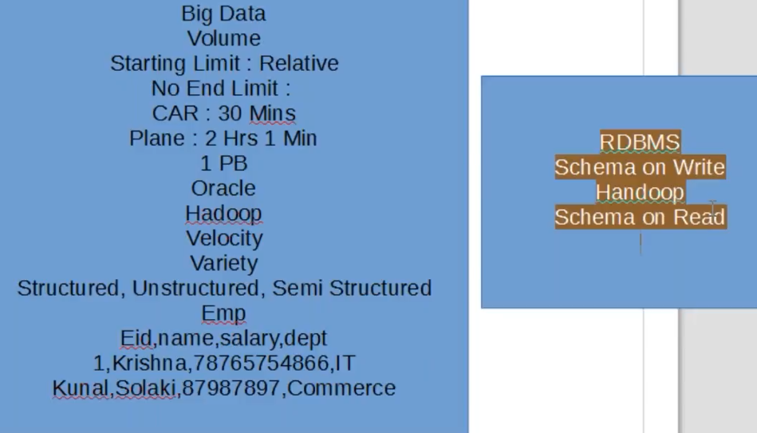

***Below eg of Semistructured data***

***JSON***

***XML***

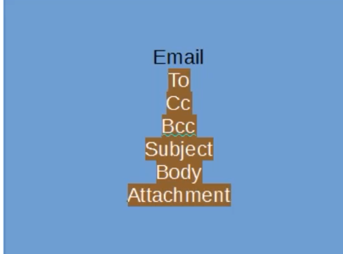

***Note*** : plain text is uns data

Different sources of BIG Data

* Telecom is a source of data generation
* Monika given call to priyankar
* Call lasted for 7 seconds
* Call result into “Call detailed record”, ie CDR.
* One CDR contain 300 fields
* Whatever we are doing it’s recorded in those 300 fields.
* Telecom has billion and billion of customer, and together as a whole, It’s a huge and huge source of generation
* Telecom has generated almost 35 TB of data on almost daily basis.
* This figure is before the launch of reliance JIO, after the launch of jio the data generation got multiple folds.
* So now the volume is much higher than this.

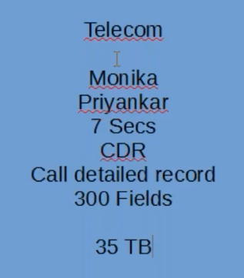

* NYSE daily generated 7TB of data.
* All the device become smart because of data only

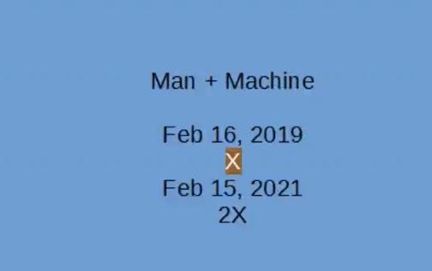

* Why we want to process big data